You will need to create a 1-page proposal that includes:

1. A brief articulation of your chosen topic and rationale
2. A link to your data set(s) and a screenshot of the metadata if it exists.
3. 3 or 4 screenshots of relevant, “inspiring” visualizations that frame your creative fodder
4. A sketch of the final design
5. A link to the primary GitHub repository you’ll be housing your work in

---------------------------------------------------------------------------------------------------

**Topic**: World Happiness-Determining how happiness compares across different countries around the world

**Link to Dataset**: <https://www.kaggle.com/unsdsn/world-happiness>

**Visualization of our framework**

Dropdown for Country

Dropdown for Year

Interactive World Happiness Visualization with options to select from

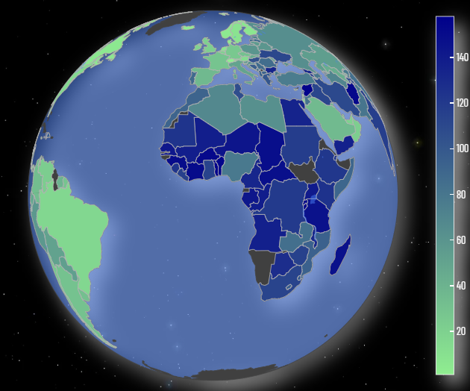

Happiness Score visualized by a Gauge Graph

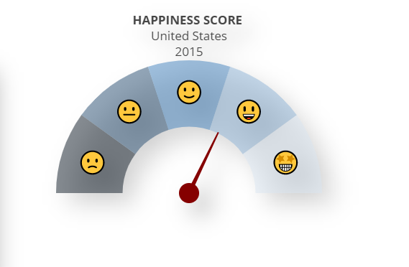

Exploring all the factors that result in the overall happiness in a country

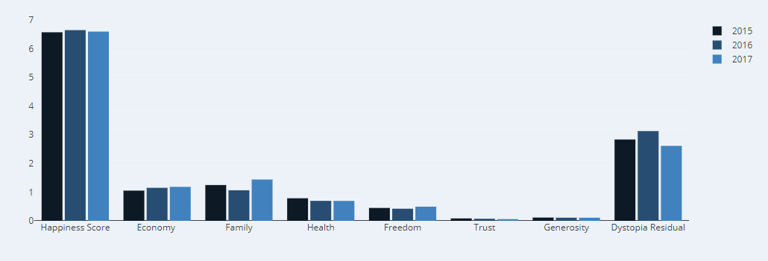

CORRELATION BETWEEN THE VARIABLES OF HAPPINESS

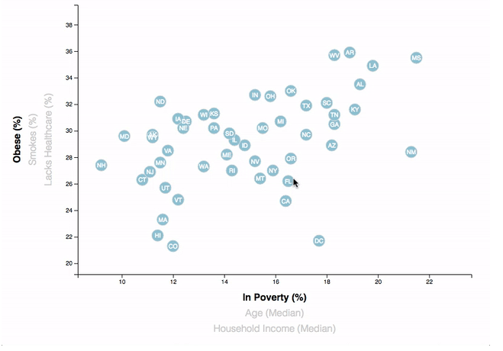

Happiness Data being viewed as the data

|  |  |  |
| --- | --- | --- |
| Factors | Data | Description |
| Happiness Score |  |  |
| Happiness Rank |  |  |
| Economy ( GDP per Capita) |  |  |
| Family |  |  |
| Health |  |  |

**Sketch of Final Design**

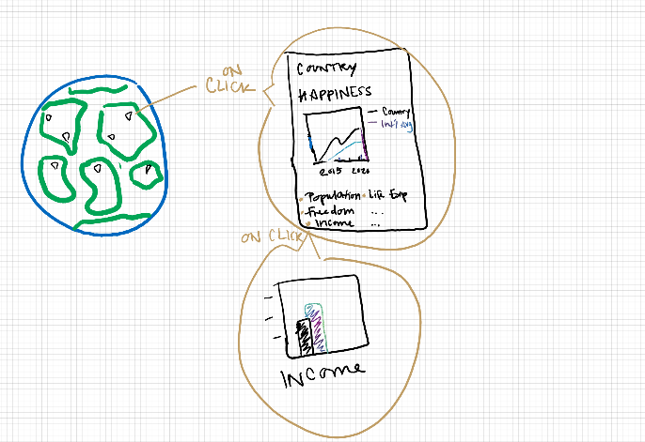

**Link to GitHub Repository:** <https://github.com/sebringjulia/UCI_project2>